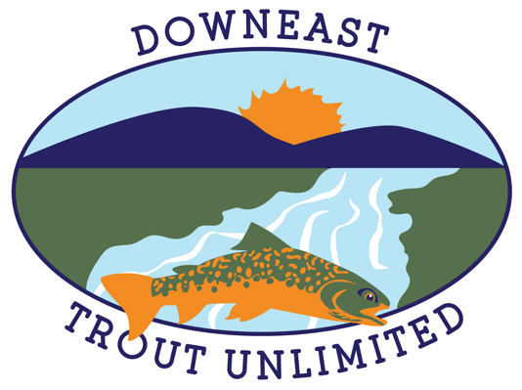
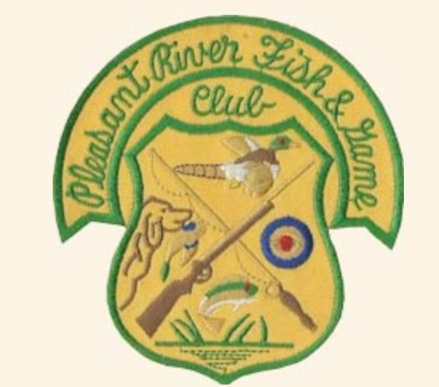

Eastern Maine Fly-Casting Competition & Fishing Exhibition Weekend
June 13 & 14 2026
Pleasant River Fish & Game Conservation Association
1597 Tibbetstown Rd. Columbia, Maine

Prizes in 2 categories: Men • Women

With 3 events: Distance • Accuracy • Obstacles: Competitors count best of 2 casts per trial using a standard fly and leader on a one-handed rod (9’ max).

Compete for prizes and bragging rights for being the best fly caster in Eastern Maine! Grab a friend to compete as a team.

All-Day Two-Day Event 10a-4p each day

Events • Demonstrations • Hands on • Speakers • Activities for All
Rod/reel set-up • Fly Tiers • Organization tables • Vendors • Food

General Admission $10 • Sell & Swap Tables $15 • Lunch $10 • Competition $20

Hosted by Downeast Trout Unlimited and PRF&GCA
Contact Al West: 207-632-7267 text/call or
aldime04658@gmail.com for information.

